|  |
| --- |
| **Exercises from old exams to chapters in B & W with solutions.** |

|  |
| --- |
| **Chapter 11 and 12** |

**Exercise 1**

Answer the following statements as **true** or **false**, and explain why. Write no more than three sentences on each question.

1. The marginal propensity to consume must be larger than one.

**Answer:**

**False:** The propensity to consume has to be (positive and) smaller than one, so that you consume a proportion out of your income (and not more than your income).

1. An increase of one unit in the government spending leads to an increase of more than one unit in equilibrium output in an IS-TR model.

**Answer:**

**True:** In the first round, output will increase by one unit. This leads to an equal increase in income, which increases consumption (by the propensity to consume) and then output equally, and so on. The final effect depends on the multiplier.

1. An increase in government spending shifts the IS curve to the left.

**Answer:**

**False:** An increase in government spending increases output, therefore the IS curve must shift to the right, increasing output and the interest rate.

1. If the central bank reduces its target rate the TR schedule shifts upwards and to the left.

**Answer:**

**False:** If the central bank reduces its target rate the TR schedule shifts downwards and to the right.

1. An appreciation leads to an immediate improvement in the competitive ability.

**Answer:**

**False:** An appreciation will increase import and reduce export, therefore worsening the competitive ability.

1. The Taylor rule implies that if inflation is below target, the central bank should increase the nominal interest rate above the desired level.

**Answer:**

**False:** If inflation is below the target, the central bank should reduce the interest rate to stimulate demand and increase prices.

**Exercise 2**

1. Use a small open economy version of the IS-TR model, known as the Mundell-Fleming model to explain devaluation under fixed exchange rates.

**Answer:**

A devaluation shifts the IS curve to the right, output increases.

1. As a follow up to question a), explain what the central bank must do to keep the domestic interest rate equal to the foreign rate of return?

**Answer:**

The central bank must increase the money supply to keep the domestic interest rate equal to the foreign rate of return.

**Exercise 3**

1. Define the curves in a IS TR model and explain the slope of the curves (ignore international trade in financial assets).
2. Explain what will happen if the economy is above the IS curve and above the TR curve.
3. Use the IS TR model to discuss the effect of an expansionary fiscal policy.

**Answer:**

1. IS curve: For given values of exogenous variables, the IS curve represents the combinations of nominal interest rate and real GDP that are consistent with goods market equilibrium. TR curve: a graphical representation of the Taylor rule, which states that central banks adjust the interest rate to reduce fluctuations in output (assuming prices constant in the short run). The IS curve slopes down and becomes flatter the greater the sensitivity of demand to changes in interest rates and the larger the multiplier that translates the initial exogenous change into higher total demand. The TR curve slopes upwards meaning that if output rises relative to its trend level, central banks raise interest rates.
2. All points above the IS curve imply an excess supply of goods. It will lead to decreased production. All points above the TR curve imply that interest rates are above the level consistent with the central bank’s monetary policy – the central bank can be expected to take action to reduce them.
3. Explained by shifting the IS curve to the right. New equilibrium at a higher interest rate (because the central bank increases the interest rate) and a higher level of production (real GDP).

**Exercise 4**

Consider a small open economy version of the IS-TR model, known as the Mundell-Fleming model.

1. Explain the IS curve, the TR curve and the international financial markets (IFM) line.

**Answer:**

The IS curve represents the equilibrium in the goods market, the TR curve describes the Central Banks behavior and the IFM line describes the interest rate at which net capital inflows are zero.

1. In a Mundell Fleming model, explain the loss of monetary policy autonomy under a fixed exchange rate regime.

**Answer:**

If a central bank lower interest rates below the foreign rate of return, capital will flow out. This weakens the currency on the foreign exchange market. In order to honor its fixed exchange rate commitment, the central bank must intervene and buy back its currency. When it performs this transaction it withdraws money from circulation, and the money supply declines. Whatever money is supplied on the open market must be promptly removed from the foreign exchange market.

1. In a Mundell Fleming model, explain a demand shock under flexible exchange rates.

**Answer:**

An expansionary demand shock shifts the IS curve to the right, (increasing income and interest rate), but if higher interest rates domestic than abroad then capital flows in. The exchange rate appreciates, external competitiveness declines, and the IS curve shifts back to its initial position. Demand disturbances are eliminated over time.

The opposite of this if a contractionary shock.

**Exercise 5**

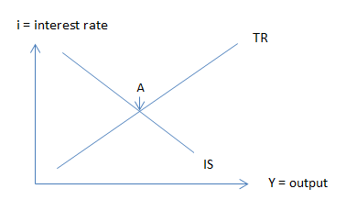Suppose the goods market and the money market can be explained by the figure at the right hand side (IS-TR model).

1. Define the curves and explain point A
2. Use the model to explain the effect on output of a real exchange rate decrease.
3. Explain part b) more in detail by dividing the total effect on output into a multiplier effect (no interest rate change) and a central bank response.

**Answer:**

1. Point A where both the goods and money markets are in equilibrium simultaneously.
2. If the real exchange rate is defined according to the british term (foreign currency units per domestic units) a decrease would be a depreciation. With constant prices this would increase international competitiveness and increase net exports, increasing aggregate demand and shift the IS curve to the right.
3. 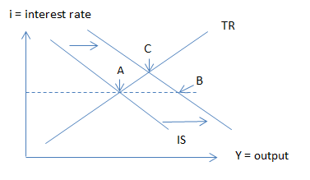This could be explained by using a figure like the one the right hand side. From point A to point B to explain the multiplier effect (without increasing interest rate). You get a larger increase in output than your initial increase caused by the exchange rate depreciation. And then from point B to point C: When output increase, the central bank increase the interest rate according to the TR curve. Then output decline until we reach a new equilibrium point C where both the goods - and the monetary market are in equilibrium.

**Exercise 6**

1. Define the curves in a Mundell-Fleming model (the IS-TR-IFM model).
2. Explain why it is important to distinguish between the types of exchange rate regime when discussing the effect of a fiscal policy.

**Answer**:

1. IS curve: for given values of exogenous variables, the combinations of nominal interest rate (i) and real output (GDP) that are consistent with goods market equilibrium. TR curve: a graphical representation of the Taylor rule, which states that central banks adjust the interest rate to reduce fluctuations in output and inflation. IFM line: International financial markets line is the line in the open economy IS-TR diagram describing the interest rate at which net capital inflows are zero.
2. If fixed exchange rates, fiscal policy is very effective because the central bank must see to that domestic interest rate equals international interest rate. If flexible exchange rates an expansionary fiscal policy (an example of a demand shock) will lead to a total crowding out effect because external competitiveness declines.

**Exercise 7**

1. Explain two polar cases when it comes to exchange rate regimes and give examples of countries that has chosen each type.
2. Define the curves in a Mundell-Fleming model (the IS-TR-IFM model).
3. Explain by using the model from b), why it is important to distinguish between types of exchange rate regimes when to discuss the effect of an expansionary monetary policy?
4. Explain by using the model from b) the following quotation: “fixed but adjustable exchange rates provide some limited degree of monetary effectiveness.

**Answer:**

1. Two polar cases when it comes to exchange rate regimes: Fixed exchange rates (monetary authorities maintain the value of the exchange rate at a publicly announced parity) and fully floating exchange rates (The central bank takes no direct responsibility for the value of its currency, which is set on foreign exchange markets. Examples of fixed: Many countries in Europe has pegged their currency to the euro (Denmark, Bulgaria, Bosnia and Herzegovina, Croatia, Czech Republic). Examples of floating: The Eurozone, the UK, the USA, Japan and Norway.
2. IS curve: for given values of exogenous variables, the combinations of nominal interest rate (i) and real output (GDP) that are consistent with goods market equilibrium. TR curve: a graphical representation of the Taylor rule, which states that central banks adjust the interest rate to reduce fluctuations in output and inflation. IFM line: International financial markets line is the line in the open economy IS-TR diagram describing the interest rate at which net capital inflows are zero.
3. A central bank cannot choose the interest rate in an open economy and a fixed exchange rate system. The TR curve has no meaning. The central bank must intervene in the market as long as the domestic interest rate is different from the foreign interest rate. The loss of monetary policy autonomy is a consequence of full capital mobility. This is different if a central bank let the exchange rate be set on foreign exchange markets. Then a change in the monetary policy will affect the exchange rate and then the competitiveness of the country. The conclusion from the model will be that monetary policy is a powerful instrument for adjusting business cycles in the short run.
4. If a central bank nominal revaluate (an increase in the external value) or devaluate, it will lead to a change in the real exchange rate (when we assume in the short run that the price levels at home and abroad are given). This will change the countries competitiveness and we explain it by shifting the IS curve. Monetary effectiveness refers to the effect on production (GDP).

**Exercise 8**

1. Explain the Keynesian multiplier.
2. Define the Taylor rule and explain how it is used differently in the short run compared to the long run.
3. Explain by using a Mundell-Fleming model (the IS-TR-IFM model) the effect of an expansionary monetary policy under flexible exchange rates. Refer to fig 1 if desired. 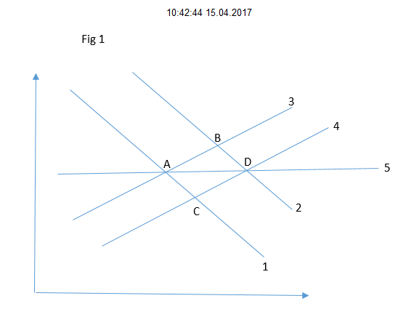

**Answer:**

1. The Keynesian multiplier. The multiplier effect corresponds to the fundamental insight provided by the circular flow diagram in chapter 2. Each individual’s spending is someone else’s income. By raising incomes, an exogenous increase in demand generates additional desired demand, which means more spending and income, a never ending process, although at each stage, the effect becomes smaller, and eventually dies out. The circular flow diagram showed where these leakages occur: taxes, savings, and imports each capture a portion of any additional income.
2. The Taylor rule states that the central bank increases the interest rate relative to the neutral level if the inflation rate rises relative to its target rate (inflation gap), or if output rises relative to its trend level (output gap). In the short run prices are assumed to be constant. Then the central bank increases the interest rate whenever output increases relative to potential output (output gap).
3. When the exchange rate is floating monetary policy becomes powerful when it comes to affecting GDP. This is because the exchange rate becomes endogenous. Its movements affect the economy’s competitiveness and therefor the position of the IS curve. In fig 1: start from point A, line 1 (IS), line 3 (TR) and line 5 (IFM). Shifting TR right (line 4). Point C both equilibrium in the goods and money market, but not in international financial markets. At point C, the lower interest rate triggers capital outflows and the exchange rate depreciates. The resulting gain in competitiveness raises demand for domestic goods and the IS curve shifts to the right (line 2). New equilibrium point D.

**Exercise 9**

What makes the IS curve flatter and how will this affect an expansionary fiscal policy according to the model?

**Answer:**

The more equilibrium output rises in response to a given reduction of the interest rate, the flatter the IS curve. Then the higher the marginal propensity to consume, the higher multiplier and then the flatter the IS. Then the effect on GDP of an expansionary fiscal policy will be higher the flatter the IS curve.

**Exercise 10**

1. What are the main assumptions when we study the short run behaviour of the economy?
2. What are the main factors and how do they drive private consumption?
3. Explain the situation if we are off the IS curve.

**Answer:**

1. Assumptions in the short run: Most important: constant prices. Others are demand driven model and general equilibrium.
2. Private consumption is driven by wealth and disposable income. When either increase, private consumption increase.
3. A diagram with output on the horizontal axis and nominal interest rate on the vertical axis the IS curve slops down. Off the IS curve to the right we have excess supply of goods and to the left we have excess demand.